**IT24103761**

**Buddhika M.D.V**

**SLIIT – Malabe**

**Probability and statistics – IT2120**

**Labsheet 09**

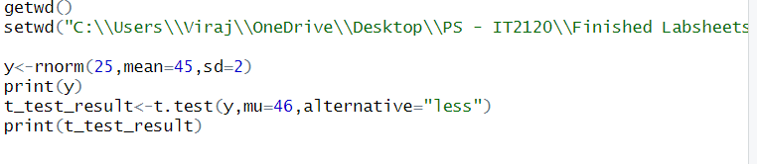

**output**



